# **C++ Programming Course Outline (Covered Topics)**

### **1. Introduction to Programming and C++**

* **What is programming?**
* **Basics of C++ syntax**
* **Writing your first program (Hello World)**
* **Input and output (cin, cout)**
* **Data types and variables**

### **2. Control Structures**

* **Conditional statements (if, else, switch)**
* **Loops (for, while, do-while)**

### **3. Functions**

* **What are functions?**
* **Defining and calling functions**
* **Function parameters and return values**

### **4. Arrays**

* **Declaring and initializing arrays**
* **Accessing and modifying elements**
* **Looping through arrays**
* **Taking user input in arrays**
* **Summing array elements**

### **5. Strings**

* **String basics in C++**
* **Using string class**
* **Input and output of strings**
* **String manipulation basics**

### **6. Pointers**

* **What is a pointer?**
* **Pointer declaration and usage**
* **Pointer arithmetic basics**
* **Pointer to pointer concept**

### **7. Structures (struct)**

* **Defining structures**
* **Declaring structure variables**
* **Array of structures**
* **Nested structures**
* **Passing structures to functions**

### **8. File Handling**

* **Introduction to file handling**
* **Writing to files using ofstream**
* **Reading from files using ifstream**
* **Reading files line by line**
* **Closing files properly**

## 

## **🌱 1. What is Programming?**

Programming means giving instructions to the computer so it can do a task for you — like adding numbers, showing messages, or saving data.

## **💻 2. C++ Programming (Basic)**

C++ is a programming language used to tell the computer what to do.

**✨ Your First C++ Program**

#include<iostream>

using namespace std;

int main() {

cout << "Hello, Usama!";

return 0;

}

| **Line** | **Meaning** |
| --- | --- |
| #include<iostream> | Tells the computer to use input/output functions (like cout). |
| using namespace std; | Lets you write cout instead of std::cout. |
| int main() | Starting point of the program. |
| cout << "Hello, Usama!"; | Shows message on the screen. |
| return 0; | Ends the program successfully. |

**Some Important concepts in C++:**

### **📍 1. cout**

* Used to print something on the screen.
* Example: cout << "Welcome!";

### **📍 2. Semicolon (;)**

* Every statement in C++ ends with a ;.

### **📍 3. Comments**

* Used to explain code (not run by computer).
* Single line: // This is a comment
* Multi-line:

/* This is a

multi-line comment */

**Task: Write a program that shows:**

My name is Usama.

I love programming.

**Program:**

#include<iostream>

using namespace std;

int main() {

cout << "My name is Usama.\n";

cout << "I love programming.";

return 0;

}

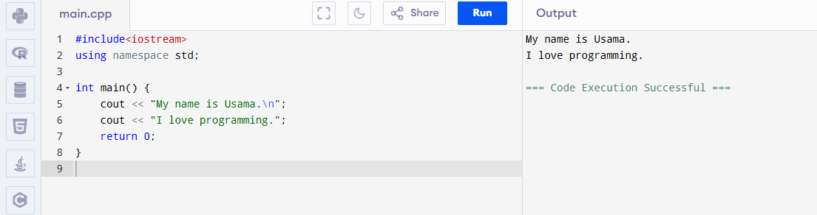

**Variables and Data Types in C++:**

## **💡 What is a Variable?**

A **variable** is like a **box** that stores information.

Example:  
 If you want to store your age, you can create a box (variable) called age.

## **🔤 What is a Data Type?**

**Data types** tell the computer **what kind of data** you are storing in the variable.

## **Common Data Types in C++**

| **Data Type** | **Meaning** | **Example** |
| --- | --- | --- |
| int | Integer (whole number) | 10, 25, -5 |
| float | Decimal number | 3.14, 7.5 |
| char | Single character | 'A', 'z' |
| string | Text (words or sentence) | "Usama", "Hello" |
| bool | True or False | true, false |

## **🧪 Examples:**

### **1. Integer:**

int age = 21;

cout << "Age: " << age;

**2. Float:**

float pi = 3.14;

cout << "Value of PI: " << pi;

**3. Char:**

char grade = 'A';

cout << "Your grade is: " << grade;

**4. String:**

string name = "Usama";

cout << "Hello " << name;

Note: To use string, add #include<string> at the top

**5. Boolean:**

bool passed = true;

cout << "Passed: " << passed;

## **Input from User**

Let the user type their own value.

#include<iostream>

#include<string>

using namespace std;

int main() {

string name;

int age;

cout << "Enter your name: ";

cin >> name;

cout << "Enter your age: ";

cin >> age;

cout << "Hello " << name << ", you are " << age << " years old.";

return 0;

}

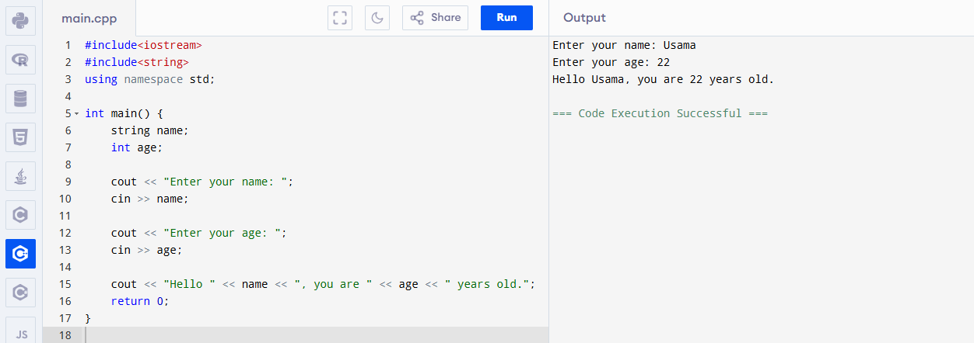

📌 If you want to input full name (with spaces), use getline(cin, name); instead of cin >> name;

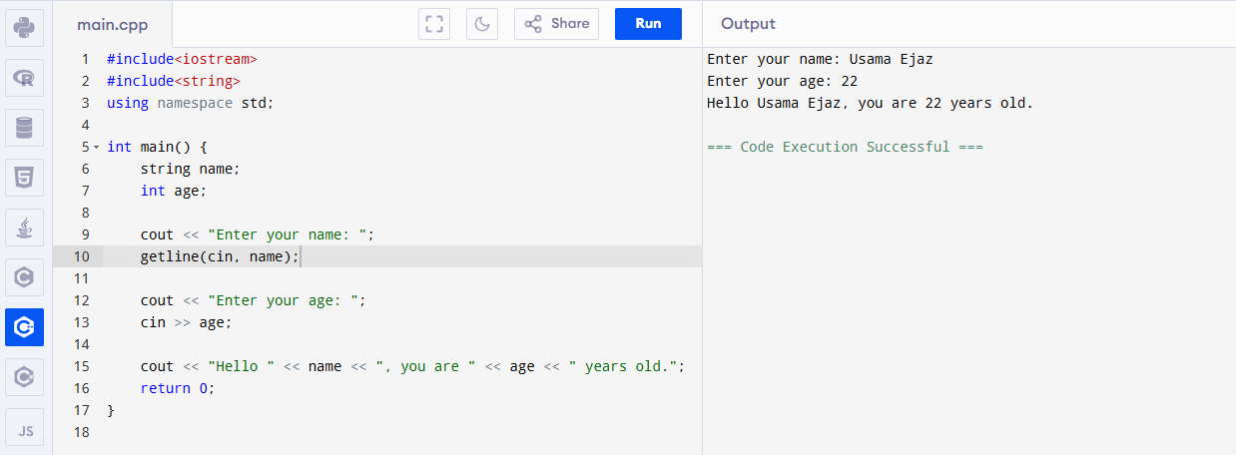

**Task**

#include <iostream>

#include <string>

using namespace std;

int main() {

// Ask the user for their name, city, and age

string name, city;

int age;

cout << "Please enter your name: ";

getline(cin, name);

cout << "Please enter your city: ";

getline(cin, city);

cout << "Please enter your age: ";

cin >> age;

// Print the message

cout << "Hello " << name << ", you are " << age << " years old and live in " << city << "." << endl;

return 0;

}

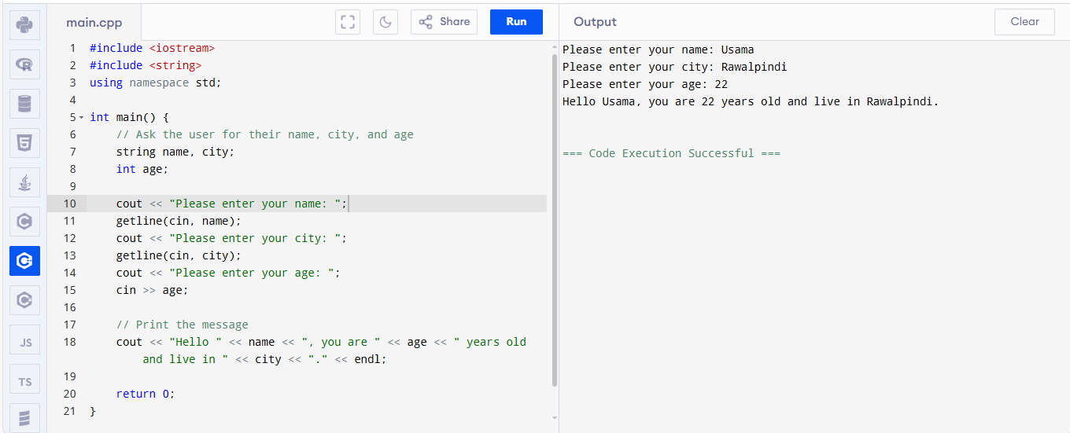

**Operators and Conditions (if/else):**

## **💡 What Are Operators?**

Operators are symbols that perform actions like math, comparison, or logic.

## 

## 

## 

## **➕ 1. Arithmetic Operators (used for math):**

| **Operator** | **Meaning** | **Example (a = 10, b = 3)** | **Result** |
| --- | --- | --- | --- |
| **+** | **Add** | **a + b** | **13** |
| **-** | **Subtract** | **a - b** | **7** |
| **\*** | **Multiply** | **a * b** | **30** |
| **/** | **Divide** | **a / b** | **3** |
| **%** | **Remainder** | **a % b** | **1** |

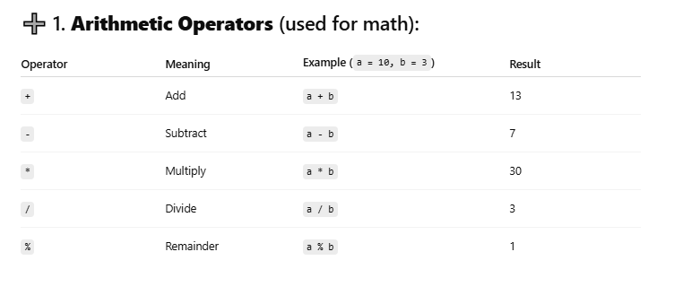

**🧪 Example:**

int a = 10, b = 3;

cout << "Sum: " << a + b;

## **⚖️ 2. Comparison Operators (used to compare values):**

| **Operator** | **Meaning** | **Example** | **Result** |
| --- | --- | --- | --- |
| == | Equal to | a == b | false |
| != | Not equal to | a != b | true |
| > | Greater than | a > b | true |
| < | Less than | a < b | false |
| >= | Greater or equal | a >= b | true |
| <= | Less or equal | a <= b | false |

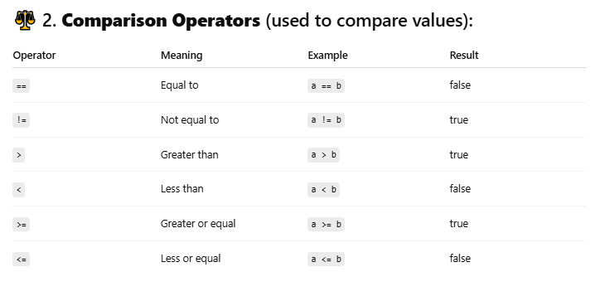

## **🤔 What is if/else?**

if and else are used to **make decisions** in a program.

**3. if/else Condition Example:**

#include <iostream>

#include <string>

using namespace std;

int main() {

int age;

cout << "Enter your age: ";

cin >> age;

if(age >= 18) {

cout << "You are an adult.";

}

else {

cout << "You are a minor.";

}

return 0;

}

### **💭 What it does:**

* If age is 18 or more → says "adult"
* Otherwise → says "minor"

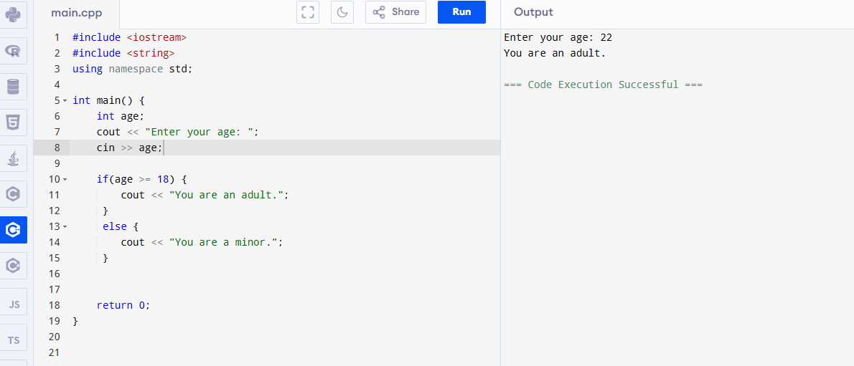

**4. else if Condition Example:**

#include <iostream>

#include <string>

using namespace std;

int main() {

int marks;

cout << "Enter your marks: ";

cin >> marks;

if (marks >= 90) {

cout << "Grade A";

} else if (marks >= 75) {

cout << "Grade B";

} else if (marks >= 60) {

cout << "Grade C";

} else {

cout << "Fail";

}

return 0;

}

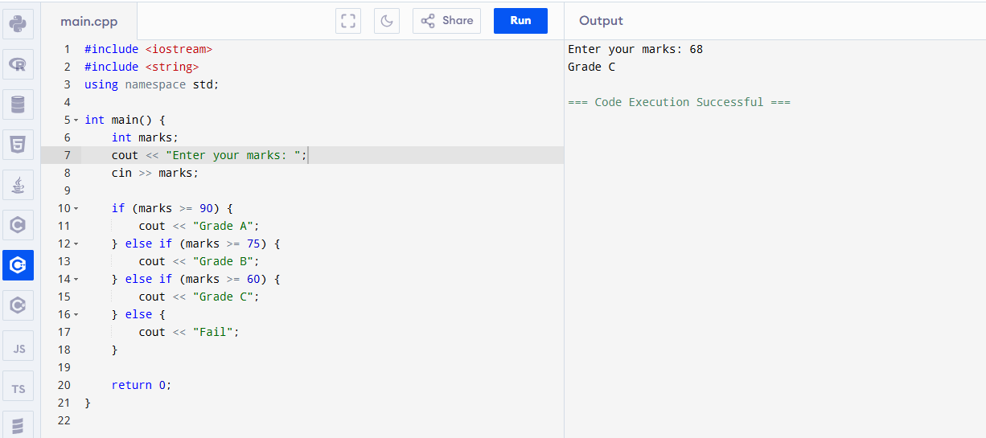

## **Extra: Logical Operators**

| **Symbol** | **Meaning** | **Example** |
| --- | --- | --- |
| && | AND | a > 5 && b < 10 |
| ` |  | ` |
| ! | NOT | !(a == b) |

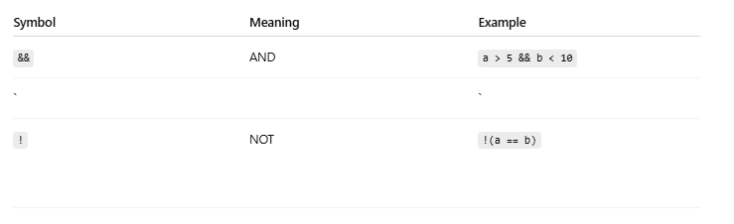

## **Task:**

Make a program that:

1. Asks for your **math marks**.
2. If marks are >= 50 → print "You passed math!"
3. Otherwise → print "You failed math."

#include <iostream>

using namespace std;

int main() {

int mathMarks;

// Ask for math marks

cout << "Enter your math marks: ";

cin >> mathMarks;

// Check if marks are >= 50

if (mathMarks >= 50) {

cout << "You passed math!" << endl;

} else {

cout << "You failed math." << endl;

}

return 0;

}

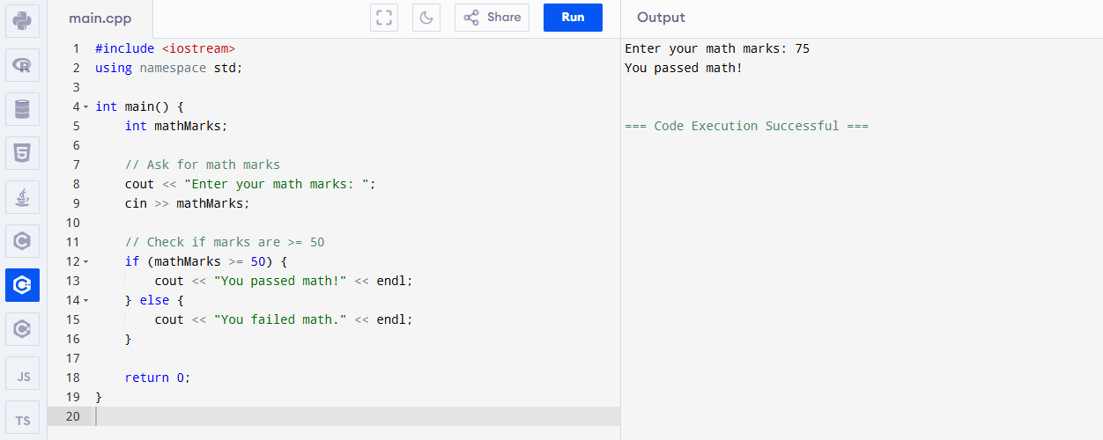

**Loops in C++:**

## **💡 What is a Loop?**

A **loop** means **repeat something again and again** until a condition is met.

Example:  
 If you want to print "Hello" 5 times, you don't have to write it 5 times. Just use a loop.

## **🔁 1. while loop**

### **📘 Syntax:**

while(condition) {

// code to repeat

}

Example:

#include <iostream>

using namespace std;

int main() {

int i = 1;

while (i <= 5) {

cout << "Hello Usama" << endl;

i++;

}

return 0;

}

### **Program logic**

* Start at i = 1
* Print "Hello Usama"
* Increase i by 1
* Stop when i > 5

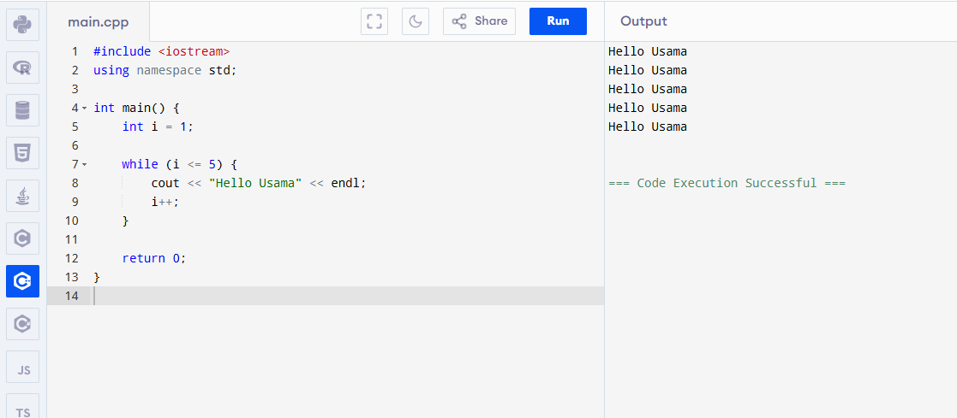

## **🔁 2. for loop**

### **📘 Syntax:**

for(start; condition; update) {

// repeat this code

}

**Example:**

#include <iostream>

using namespace std;

int main() {

for (int i = 1; i <= 5; i++) {

cout << "C++ is awesome!" << endl;

}

return 0;

}

This prints the line 5 times.

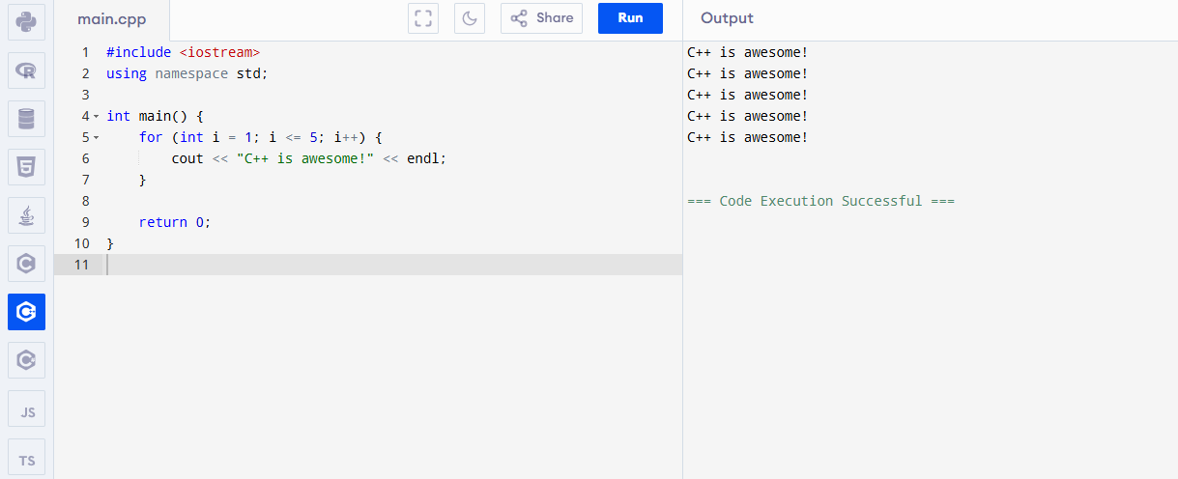

.

## **🔁 3. do-while loop**

### **📘 Syntax:**

do {

// run this

} while(condition);

Example:

#include <iostream>

using namespace std;

int main() {

int i = 1;

do {

cout << "Learning is fun!" << endl;

i++;

} while (i <= 3);

return 0;

}

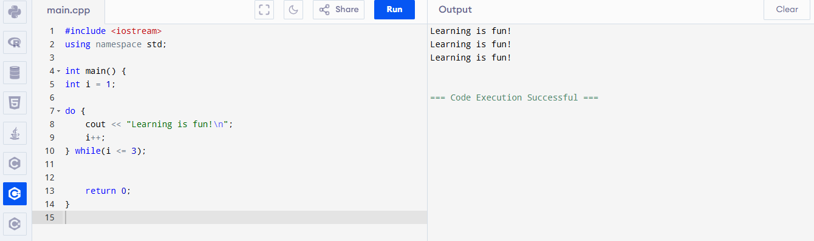

### **💡 Special Point:**

do-while runs **at least one time**, even if the condition is false.

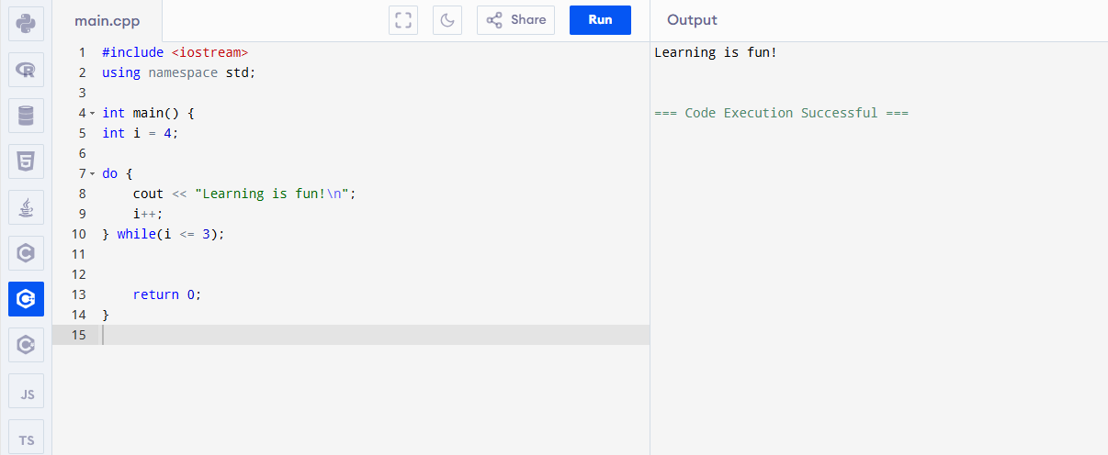

Example: Print 1 to 10:

#include <iostream>

using namespace std;

int main() {

for(int i = 1; i <= 10; i++) {

cout << i << " ";

}

return 0;

}

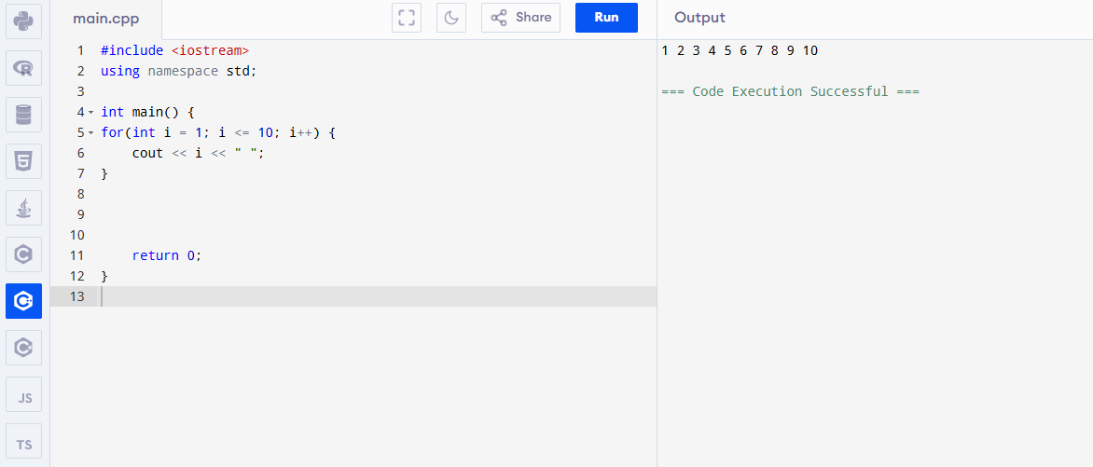

## **🚫 Break and Continue**

### **🛑 break: Stops the loop**

#include <iostream>

using namespace std;

int main() {

for (int i = 1; i <= 10; i++) {

if (i == 5)

break;

cout << i << " ";

}

return 0;

}

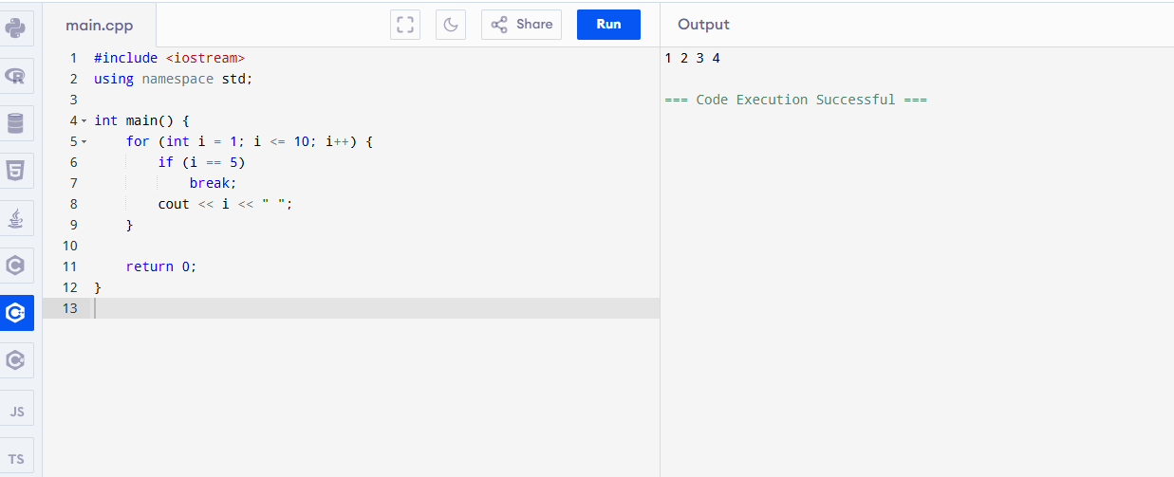

🔁 continue: Skips current step

#include <iostream>

using namespace std;

int main() {

for (int i = 1; i <= 5; i++) {

if (i == 3)

continue;

cout << i << " ";

}

return 0;

}

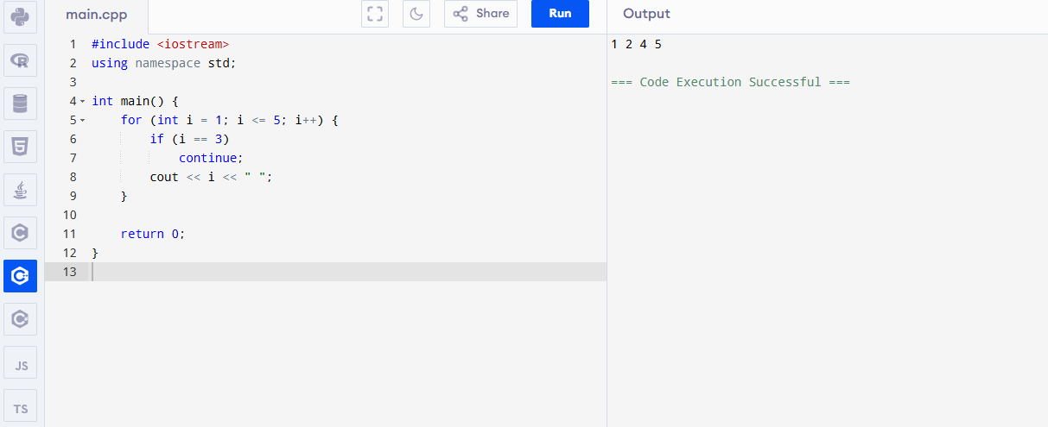

## **Task:**

Write a program to:

* Ask the user for a number.
* Print the **table** of that number up to 10.

#include <iostream>

using namespace std;

int main() {

int number;

// Ask the user for a number

cout << "Enter a number: ";

cin >> number;

// Print the multiplication table up to 10

cout << "Multiplication table of " << number << ":\n";

for (int i = 1; i <= 10; i++) {

cout << number << " x " << i << " = " << number * i << endl;

}

return 0;

}

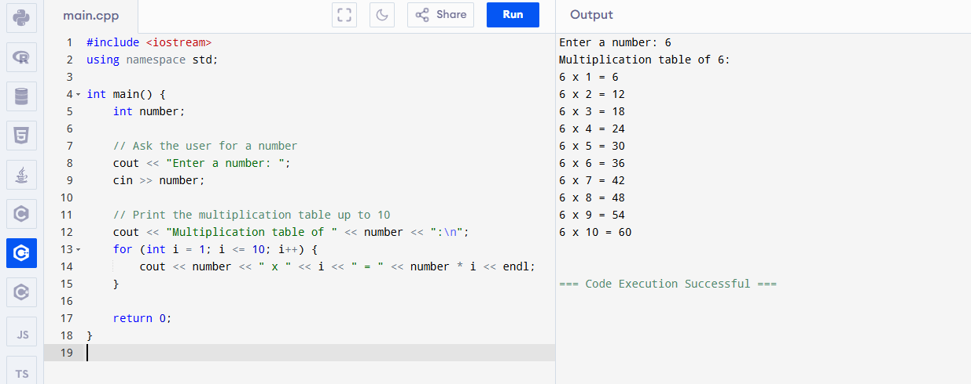

**Functions in C++**

## **🔧 What is a Function?**

A **function** is a **block of code** that does **one task**, and you can **reuse** it anywhere in your program.

👉 Think of it like a **machine**:  
 You give it something (input), it gives you something back (output).

### **🧱 1. Why Use Functions?**

* Makes code **clean**
* Makes code **reusable**
* Helps break big tasks into **small parts**

## **🧪 2. Types of Functions**

| **Type** | **Example** |
| --- | --- |
| **🔹 Built-in function** | **cout, cin, sqrt(), etc.** |
| **🔹 User-defined function** | **You create it yourself** |

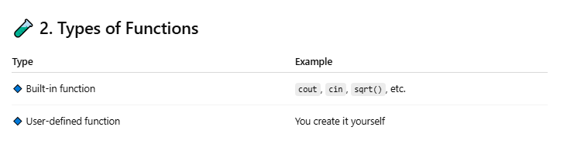

**🛠️ 3. Structure of a Function**

return_type function_name(parameters) {

// code

return something;

}

**4. Simple Example (No Return, No Parameters)**

void sayHello() {

cout << "Hello Usama!\n";

}

**To use it (call it):**

sayHello(); // This will print "Hello Usama!"

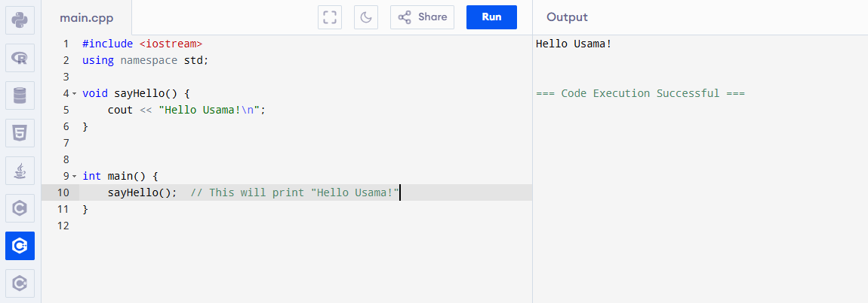

**🧮 5. Function With Parameters**

void greet(string name) {

cout << "Hello, " << name << "!\n";

}

**Call it like this:**

greet("Usama");

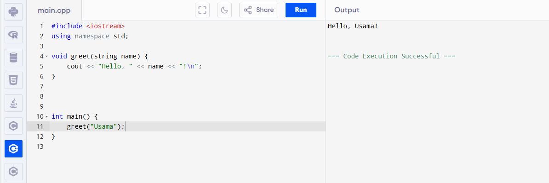

## **6. Function With Return Value**

int add(int a, int b) {

return a + b;

}

**Call it:**

int result = add(5, 3);

cout << result; // Output: 8

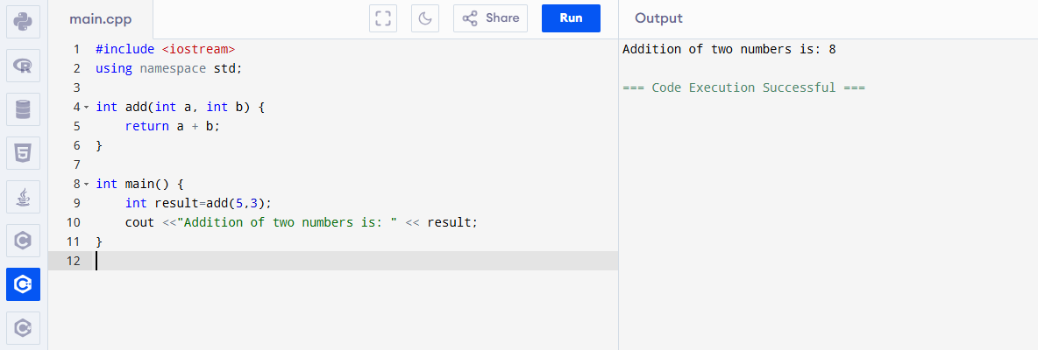

**Example:**

#include <iostream>

using namespace std;

int square(int num) {

return num * num;

}

int main() {

int result = square(4);

cout << "Square is: " << result; // Output: 16

return 0;

}

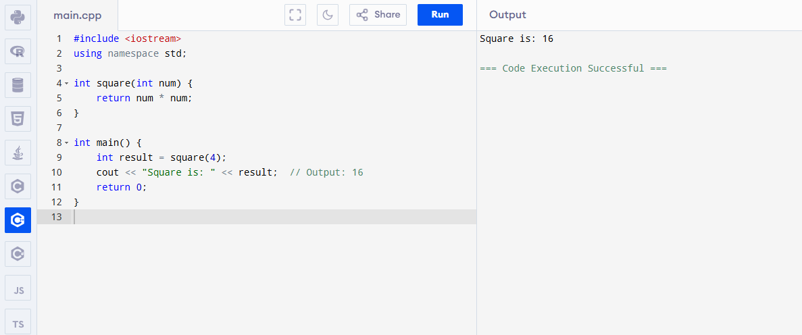

## **🤔 Function Call Flow:**

1. main() starts
2. main calls square(4)
3. square() does its job and sends result back
4. main uses the result

**Note: If you define function below main, then you must declare it first:**

int add(int, int); // Function prototype

int main() {

cout << add(3, 4);

}

int add(int a, int b) {

return a + b;

}

**Full Program:**

#include <iostream>

using namespace std;

// Function prototype or declaration

int multiply(int, int);

int main() {

int result = multiply(6, 7); // Aap yahan koi bhi numbers de sakte hain

cout << "The product is: " << result << endl;

return 0;

}

// Function definition

int multiply(int a, int b) {

return a * b;

}

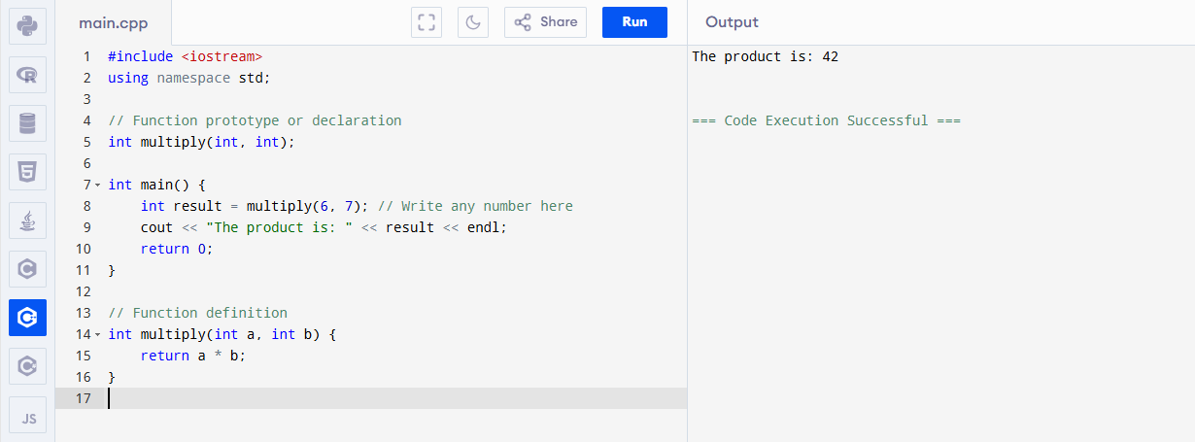

## **🧪 Task:**

**🔸 Write a function called multiply() that:**

* **takes 2 numbers**
* **returns their product**

**➡️ Then call it in main() and show the result.**

#include <iostream>

using namespace std;

// Function to multiply two numbers

int multiply(int a, int b) {

return a * b;

}

int main() {

int result = multiply(4, 5); // Aap yahan numbers change kar sakte hain

cout << "The product is: " << result << endl;

return 0;

}

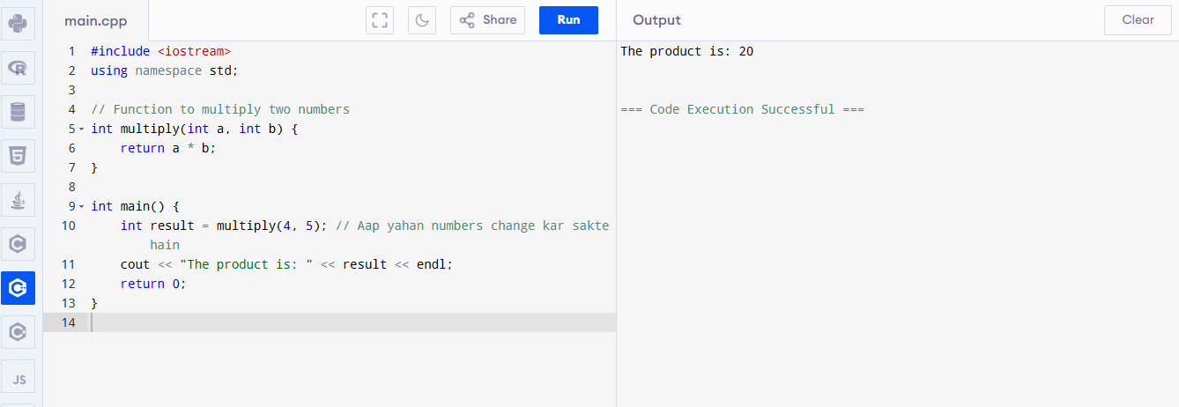

**Arrays in C++**

## **🧱 What is an Array?**

An **array** is a **box** that stores **many values** of the **same type** using **one name**.

### **Example:**

Imagine a **carton with 5 cups** inside.  
You don’t give each cup a different name — you say: “Cup[0], Cup[1], ... Cup[4]”.

## **Why Use Arrays?**

* Store lots of data in **one variable**
* Easy to **loop** through
* Helps with **sorting, searching**, and more

**🧪 1. Declaring an Array**

int numbers[5]; // an array of 5 integers

**It looks like this in memory:**

**Index: 0 1 2 3 4**

**Value: [ ] [ ] [ ] [ ] [ ]**

Indexes always start from **0.**

**2. Initializing an Array**

int nums[3] = {10, 20, 30};

**This means:**

nums[0] = 10

nums[1] = 20

nums[2] = 30

**3. Accessing and Printing Elements**

cout << nums[1]; // Output: 20

**4. Loop Through an Array**

for(int i = 0; i < 3; i++) {

cout << nums[i] << " ";

}

**Output: 10 20 30**

**✍️ 5. Take Input from User in Array**

int marks[5];

for(int i = 0; i < 5; i++) {

cout << "Enter mark " << i+1 << ": ";

cin >> marks[i];

}

**💡 6. Sum of All Array Elements**

int sum = 0;

for(int i = 0; i < 5; i++) {

sum += marks[i];

}

cout << "Total = " << sum;

## 

## 

## **Program:**

#include <iostream>

using namespace std;

int main() {

// 1. Declaring an array of 5 integers

int numbers[5]; // empty array

// 2. Initializing an array of 3 elements

int nums[3] = {10, 20, 30};

// 3. Accessing and printing one element

cout << "nums[1] = " << nums[1] << endl; // Output: 20

// 4. Loop through the nums array

cout << "Values in nums array: ";

for(int i = 0; i < 3; i++) {

cout << nums[i] << " ";

}

cout << endl;

// 5. Taking input from user in an array

int marks[5];

for(int i = 0; i < 5; i++) {

cout << "Enter mark " << i + 1 << ": ";

cin >> marks[i];

}

// 6. Calculating sum of all marks

int sum = 0;

for(int i = 0; i < 5; i++) {

sum += marks[i];

}

cout << "Total marks = " << sum << endl;

return 0;

}

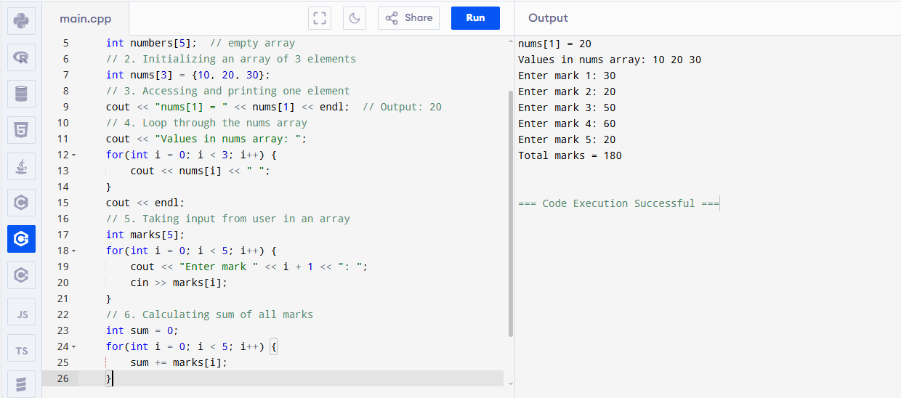

## 

## **🧪 Task:**

**Write a program that:**

* **Takes 10 numbers from user into an array**
* **Finds and prints the largest number**

#include <iostream>

using namespace std;

int main() {

int numbers[10];

// Take 10 numbers from the user

cout << "Enter 10 numbers:" << endl;

for(int i = 0; i < 10; i++) {

cout << "Number " << i + 1 << ": ";

cin >> numbers[i];

}

// Assume the first number is the largest

int largest = numbers[0];

// Compare each number to find the largest

for(int i = 1; i < 10; i++) {

if(numbers[i] > largest) {

largest = numbers[i];

}

}

// Print the largest number

cout << "The largest number is: " << largest << endl;

return 0;

}

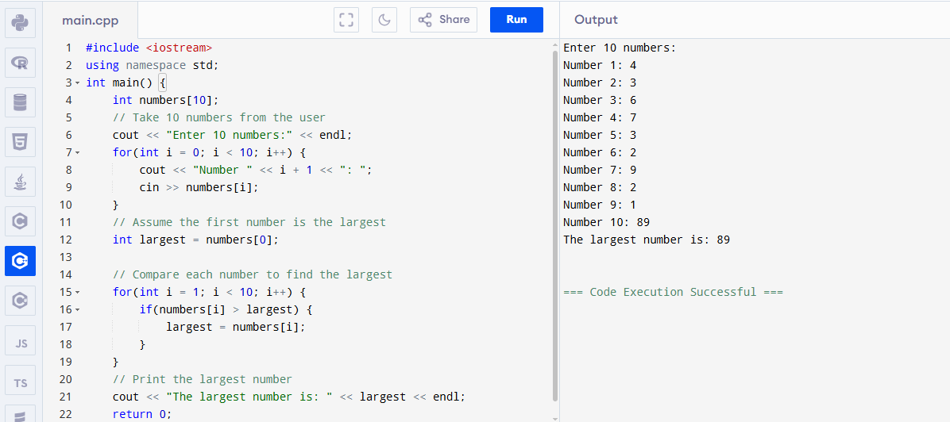

**Strings in C++**

## **🧵 What is a String?**

A string is a collection of characters (letters, numbers, symbols) that form words or sentences.

**Example:**

string name = "Usama";

**🧪 1. Declaring a String**

#include <iostream>

#include <string>

using namespace std;

int main() {

string myName = "Usama";

cout << "My name is: " << myName;

return 0;

}

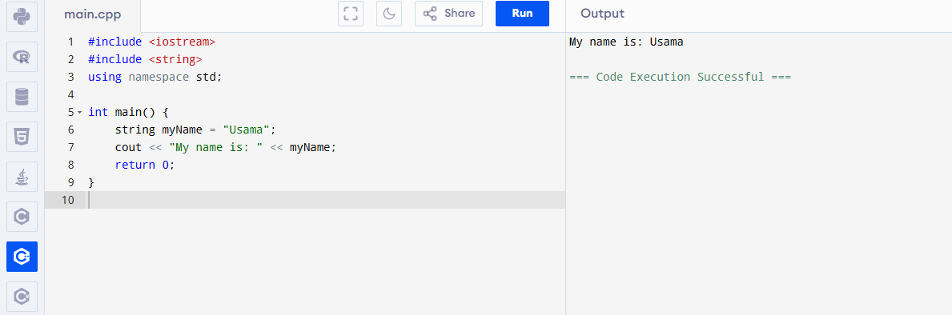

## **🛠️ 2. Taking Input from User**

### **🧍 Only one word:**

string name;

cin >> name;

**🧑‍🤝‍🧑 Full sentence (with spaces):**

string sentence;

getline(cin, sentence);

## 

## 

## 

## 

## 

## **🔍 3. Useful String Functions**

| **Function** | **What It Does** | **Example** |
| --- | --- | --- |
| **.length()** | **Counts letters** | **str.length() → 5** |
| **.at(i)** | **Character at index i** | **str.at(0) → 'U'** |
| **.append()** | **Adds more to string** | **str.append(" Ejaz")** |
| **.empty()** | **Checks if string is empty** | **true/false** |
| **.clear()** | **Empties the string** | **str.clear()** |

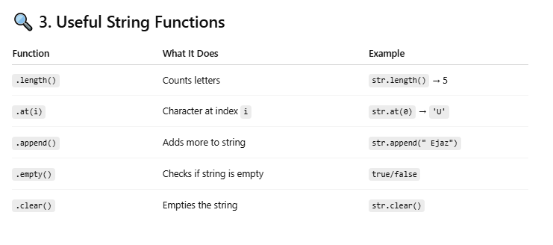

**4. Example :**

#include <iostream>

#include <string>

using namespace std;

int main() {

string name;

cout << "Enter your name: ";

getline(cin, name);

cout << "Length of name: " << name.length() << endl;

cout << "First letter: " << name.at(0) << endl;

name.append(" is learning C++");

cout << "Updated string: " << name << endl;

return 0;

}

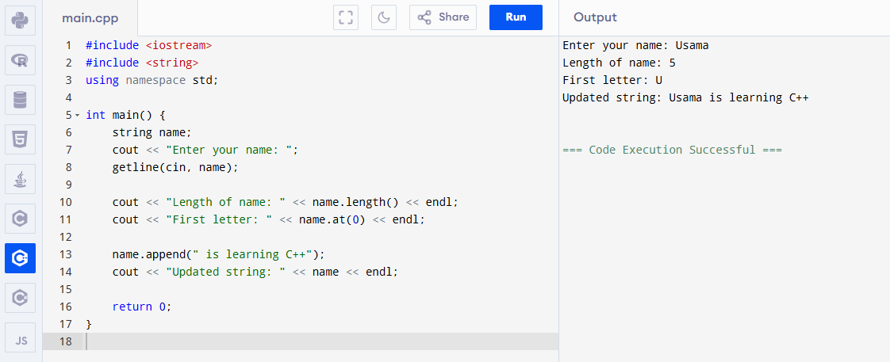

**5. Comparing Strings**

string a = "hello";

string b = "world";

if (a == b) {

cout << "Same";

} else {

cout << "Different";

}

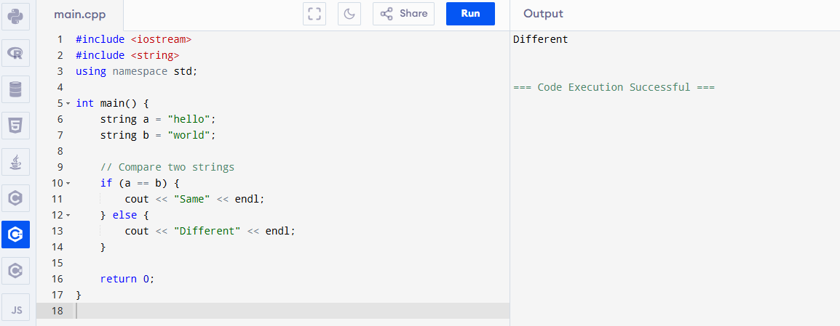

**C++ Program (Char Array vs String)**

**String as Char Array (Old Way)**

char name[20] = "Usama";

cout << name;

**But in modern C++, we prefer using string not char array.**

#include <iostream>

#include <string> // Needed for using string in modern C++

using namespace std;

int main() {

// Old Way: Using character array

char name1[20] = "Usama";

cout << "Old Way (char array): " << name1 << endl;

// Modern Way: Using string

string name2 = "Usama";

cout << "Modern Way (string): " << name2 << endl;

return 0;

}

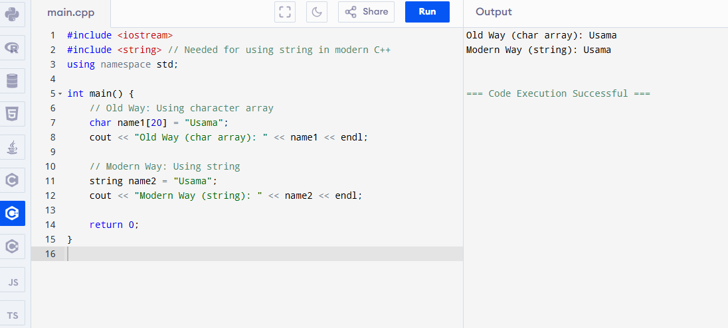

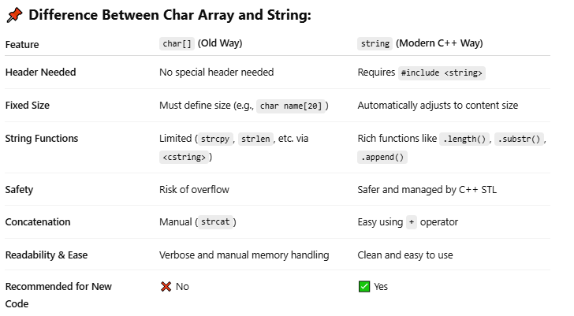

## **🧪 Task:**

**🔹 Write a program that:**

* **Takes your full name as input**
* **Shows the length**
* **Shows the first and last character**
* **Appends " is a good programmer" to it**

#include <iostream>

#include <string>

using namespace std;

int main() {

string fullname;

// Take full name as input (including spaces)

cout << "Enter your full name: ";

getline(cin, fullname);

// Show length of the name

cout << "Length of your name: " << fullname.length() << endl;

// Show first and last character

if (fullname.length() > 0) {

cout << "First character: " << fullname[0] << endl;

cout << "Last character: " << fullname[fullname.length() - 1] << endl;

} else {

cout << "Name is empty!" << endl;

}

// Append and show the message

string message = fullname + " is a good programmer";

cout << message << endl;

return 0;

}

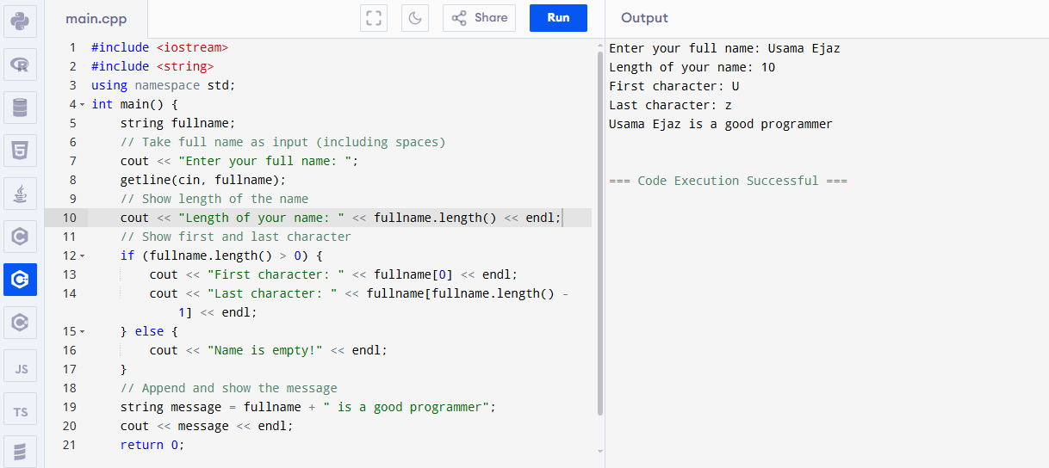

**🌟 Switch Statement in C++**

## **🔘 What is Switch Statement?**

**Switch statement ek tarah ka decision-making tool hai jo multiple options mein se ek ko select karta hai.**

## **🔎 Why use Switch?**

Instead of writing multiple if-else, switch makes code cleaner and easier to read when there is a need to check multiple cases.

**🧰 Syntax:**

switch(expression) {

case value1:

// code if expression == value1

break;

case value2:

// code if expression == value2

break;

...

default:

// code if expression doesn't match any case

}

**🧪 Example: Days of Week**

#include <iostream>

using namespace std;

int main() {

int day;

cout << "Enter day number (1-7): ";

cin >> day;

switch(day) {

case 1:

cout << "Sunday";

break;

case 2:

cout << "Monday";

break;

case 3:

cout << "Tuesday";

break;

case 4:

cout << "Wednesday";

break;

case 5:

cout << "Thursday";

break;

case 6:

cout << "Friday";

break;

case 7:

cout << "Saturday";

break;

default:

cout << "Invalid day number";

}

return 0;

}

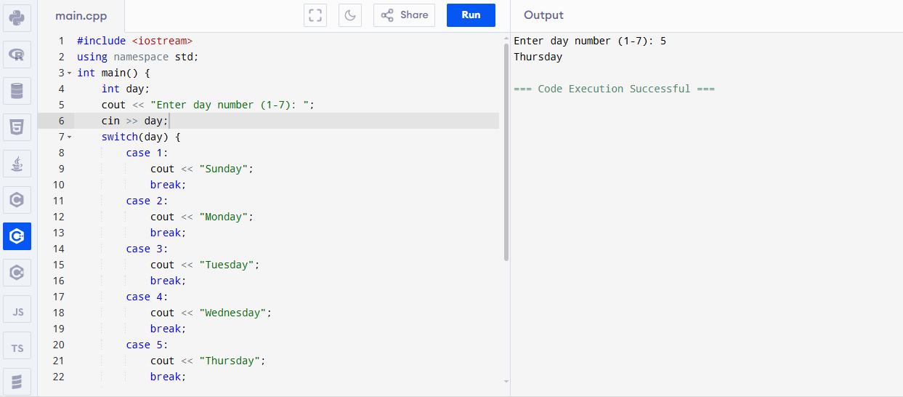

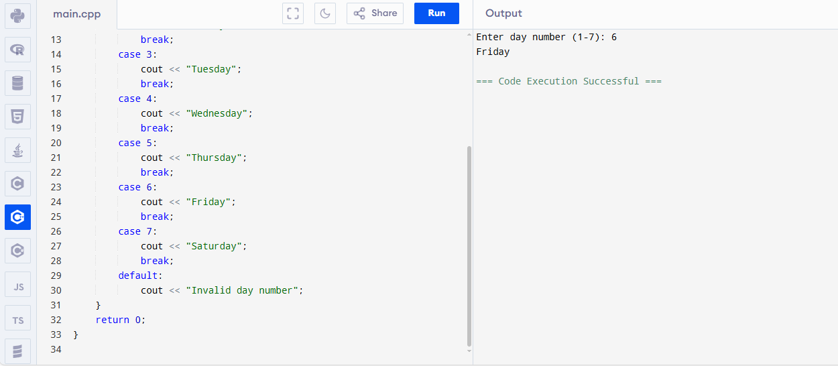

**🔑 Important Points:**

* The break statement is written at the end of each case; otherwise, the program will continue to the next case (fall-through).
* The default case is optional, but it's useful when none of the cases match.
* The switch expression can only be of type int, char, or enum (not floating-point types like float or double).

## **🧪 Task:**

**Write a program that:**

* **Takes a number from 1 to 4**
* **Prints the corresponding season:  
   1 = Spring  
   2 = Summer  
   3 = Autumn  
   4 = Winter**
* **Prints "Invalid choice" otherwise**

#include <iostream>

using namespace std;

int main() {

int choice;

// Take a number from the user

cout << "Enter a number (1 to 4): ";

cin >> choice;

// Print the corresponding season

switch (choice) {

case 1:

cout << "Spring" << endl;

break;

case 2:

cout << "Summer" << endl;

break;

case 3:

cout << "Autumn" << endl;

break;

case 4:

cout << "Winter" << endl;

break;

default:

cout << "Invalid choice" << endl;

}

return 0;

}

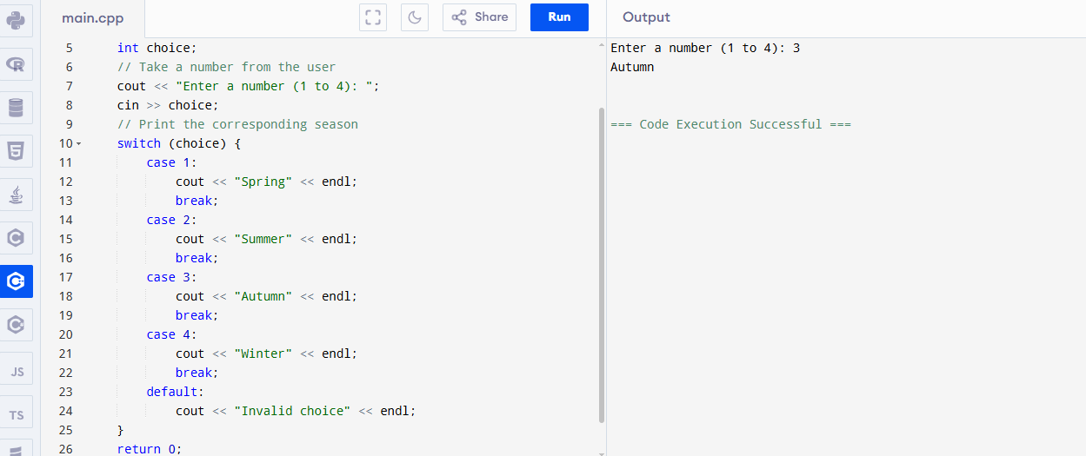

**Pointers in C++**

## **📌 What is a Pointer?**

A pointer is a variable that stores the memory address of another variable.

### **Example:**

Imagine a house.

* The house = variable
* The address of the house = pointer

**💡 Syntax:**

int a = 10;

int* ptr = &a;

* a is a normal variable
* &a gives the address of a
* ptr stores that address

**C++ Program: Understanding Pointers**

#include <iostream>

using namespace std;

int main() {

// A normal variable

int a = 10;

// A pointer that stores the address of 'a'

int* ptr = &a;

// Showing the value, address, and how pointer works

cout << "Value of a: " << a << endl;

cout << "Address of a (&a): " << &a << endl;

cout << "Value stored in ptr (address of a): " << ptr << endl;

cout << "Value pointed by ptr (*ptr): " << *ptr << endl;

return 0;

}

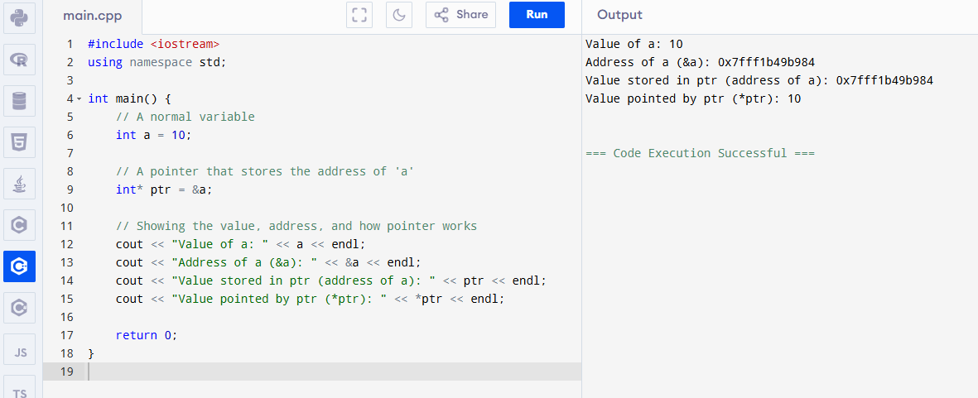

## 

## 

## 

## **🔧 Important Symbols:**

| **Symbol** | **Use** |
| --- | --- |
| **&** | **Gives the address of a variable** |
| **\*** | **Gives the value at a pointer (dereferencing)** |

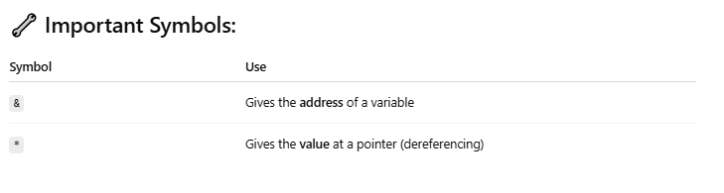

**Example:**

#include <iostream>

using namespace std;

int main() {

int a = 10;

int* ptr = &a;

cout << "Value of a: " << a << endl;

cout << "Address of a: " << &a << endl;

cout << "Pointer ptr: " << ptr << endl;

cout << "Value at pointer ptr: " << *ptr << endl;

return 0;

}

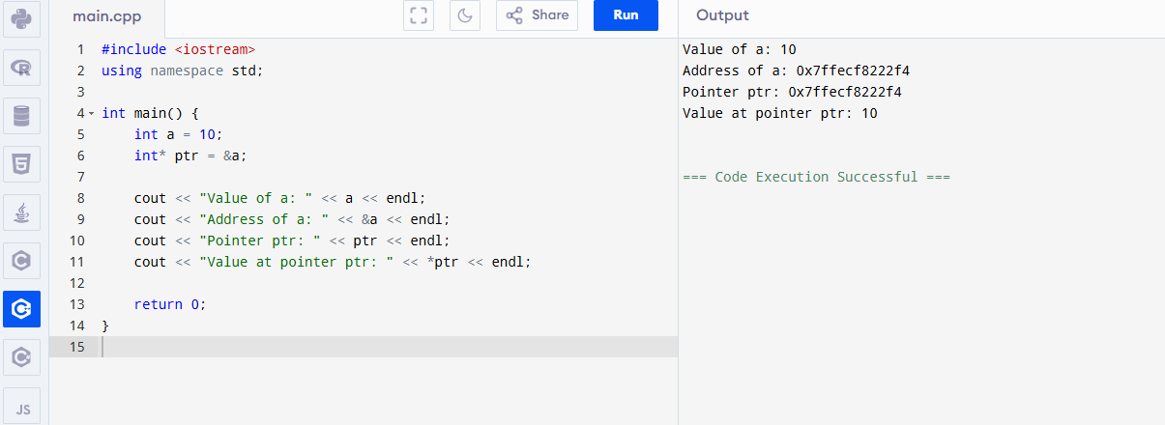

## **Why Do We Use Pointers?**

* To save memory
* To access and change values directly using address
* Used in arrays, functions, and data structures (like linked list)

## **🧪 Task :**

1. Ask user for a number
2. Store the number in a variable
3. Create a pointer to that variable
4. Print the value and address using both & and *

**C++ Program: Pointer Basics with User Input**

#include <iostream>

using namespace std;

int main() {

int number;

// Ask user for a number

cout << "Enter a number: ";

cin >> number;

// Create a pointer to the variable

int* ptr = &number;

// Show value and address

cout << "\nUsing variable name:" << endl;

cout << "Value: " << number << endl;

cout << "Address: " << &number << endl;

cout << "\nUsing pointer:" << endl;

cout << "Value (*ptr): " << *ptr << endl;

cout << "Address (ptr): " << ptr << endl;

return 0;

}

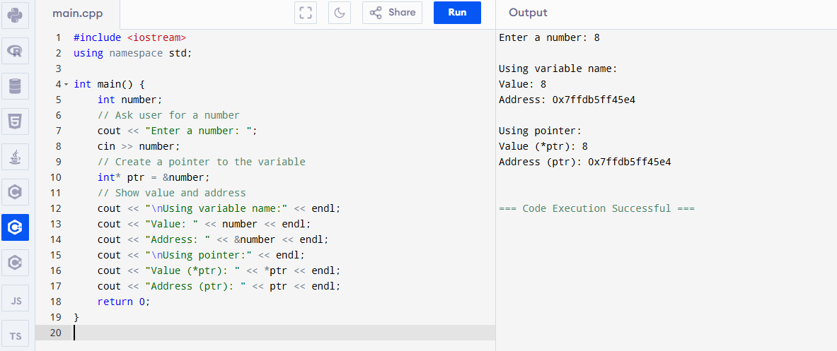

**Pointer to Pointer concept in C++:**

## **🌟 What is a Pointer to Pointer?**

Just like a normal pointer stores the address of a variable,  
 a Pointer to Pointer stores the address of a pointer.

It’s like this:

int a = 10;

int* p = &a; // p stores address of a

int** pp = &p; // pp stores address of p

## **Real-Life Analogy:**

📦 a = a gift  
 🏠 p = address of the gift  
 🗺️ pp = map where that address is written

**Example:**

#include <iostream>

using namespace std;

int main() {

int a = 10;

int* p = &a; // pointer to a

int** pp = &p; // pointer to pointer

cout << "Value of a: " << a << endl;

cout << "Value using *p: " << *p << endl;

cout << "Value using **pp: " << **pp << endl;

cout << "Address of a: " << &a << endl;

cout << "Value of p (address of a): " << p << endl;

cout << "Value of pp (address of p): " << pp << endl;

return 0;

}

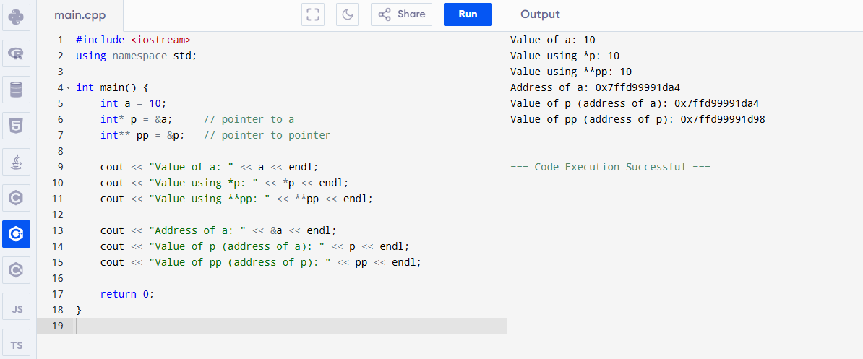

## **📌 Why use Pointer to Pointer?**

* Used in multidimensional arrays
* Needed when passing a pointer to a function (by reference)
* Used in dynamic memory allocation and advanced data structures

**Pointer Understanding flow diagram:**

**a = 10**

**p = &a → points to a**

**pp = &p → points to p**

**\*pp = p (address of a)**

**\*\*pp = a (actual value)**

**C++ Program: Pointer to Pointer Concept**

#include <iostream>

using namespace std;

int main() {

int a = 10; // normal variable

int* p = &a; // pointer to a

int** pp = &p; // pointer to pointer to a

// Print everything step by step

cout << "Value of a: " << a << endl;

cout << "Address of a (&a): " << &a << endl;

cout << "\nValue of p (address of a): " << p << endl;

cout << "Value pointed by p (*p): " << *p << endl;

cout << "\nValue of pp (address of p): " << pp << endl;

cout << "Value pointed by pp (*pp): " << *pp << endl;

cout << "Value pointed by *pp i.e., **pp: " << **pp << endl;

return 0;

}

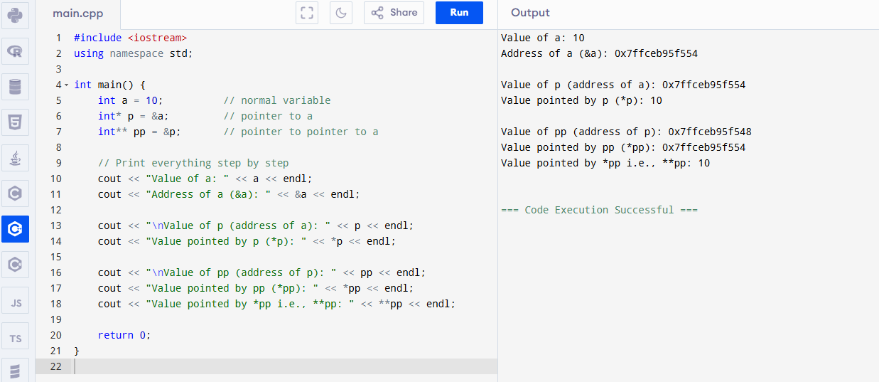

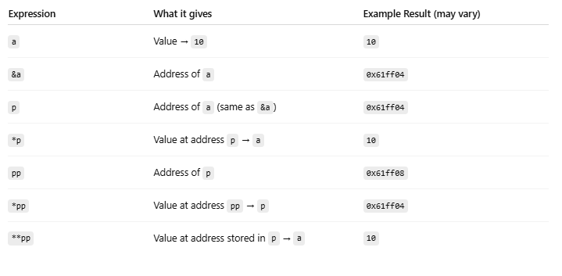

**Structures (struct) in C++**

## **📘 What is a Structure (struct)?**

A structure is a user-defined data type.  
 It lets you group different types of variables together under one name.

Think of it like a custom box 📦 where you keep related items together.

**Syntax of Structure:**

struct Person {

string name;

int age;

float height;

};

Now you can create **objects** of this structure:

Person p1;

## **Example:**

You want to store data of a student:

* Name (text)
* Roll number (number)
* Marks (decimal)

Instead of making 3 separate variables, make a structure:

struct Student {

string name;

int rollNo;

float marks;

};

Example:

#include <iostream>

using namespace std;

// Structure definition

struct Student {

string name;

int rollNo;

float marks;

};

int main() {

// Creating a structure variable

Student s1;

// Taking input

cout << "Enter name: ";

cin >> s1.name;

cout << "Enter roll number: ";

cin >> s1.rollNo;

cout << "Enter marks: ";

cin >> s1.marks;

// Printing data

cout << "\nStudent Info:\n";

cout << "Name: " << s1.name << endl;

cout << "Roll No: " << s1.rollNo << endl;

cout << "Marks: " << s1.marks << endl;

return 0;

}

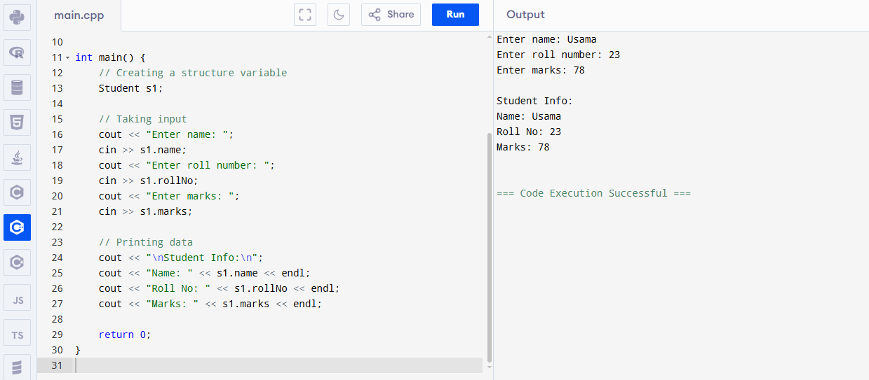

**🧪 Program: Handle Multiple Students Using struct**

* Multiple students using structure
* Structure array
* Passing structure to function

#include <iostream>

using namespace std;

// Structure definition

struct Student {

string name;

int rollNo;

float marks;

};

// Function to display one student's info (structure passed to function)

void displayStudent(Student s) {

cout << "Name: " << s.name << endl;

cout << "Roll No: " << s.rollNo << endl;

cout << "Marks: " << s.marks << endl;

cout << "-----------------------" << endl;

}

int main() {

// Array of structures (5 students)

Student students[3];

// Input data for all students

for (int i = 0; i < 3; i++) {

cout << "Enter details for student " << i + 1 << ":\n";

cout << "Name: ";

cin >> students[i].name;

cout << "Roll No: ";

cin >> students[i].rollNo;

cout << "Marks: ";

cin >> students[i].marks;

cout << endl;

}

// Displaying all students using function

cout << "\n===== All Students Info =====\n";

for (int i = 0; i < 3; i++) {

displayStudent(students[i]);

}

return 0;

}

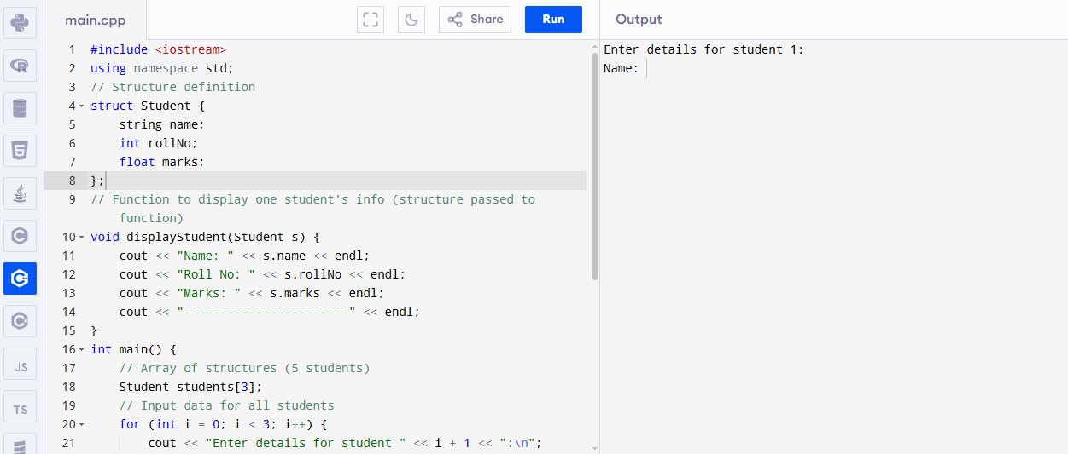

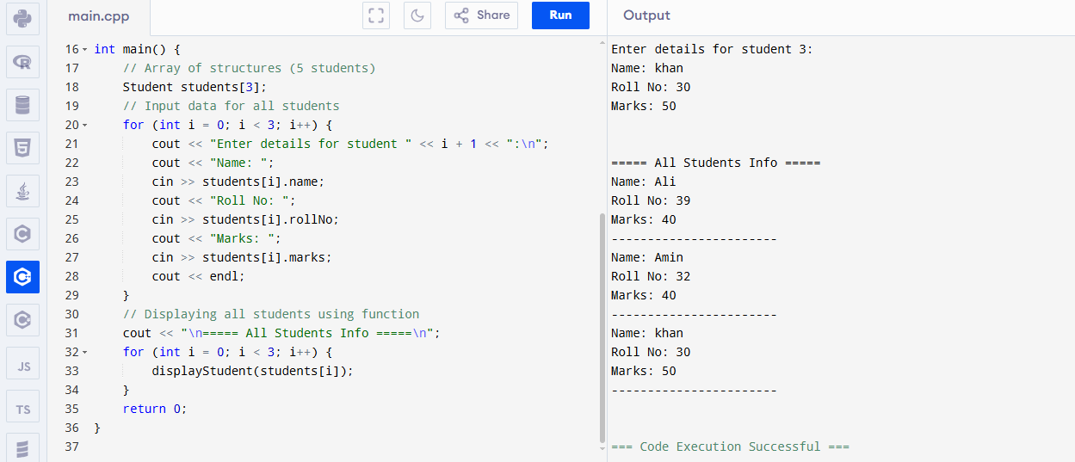

**🧩 Nested Structures Example (Student with Address)**

#include <iostream>

using namespace std;

// Address structure

struct Address {

string city;

string street;

int houseNumber;

};

// Student structure with Address inside

struct Student {

string name;

int rollNo;

float marks;

Address addr; // nested structure

};

// Function to display student info including address

void displayStudent(Student s) {

cout << "Name: " << s.name << endl;

cout << "Roll No: " << s.rollNo << endl;

cout << "Marks: " << s.marks << endl;

cout << "City: " << s.addr.city << endl;

cout << "Street: " << s.addr.street << endl;

cout << "House Number: " << s.addr.houseNumber << endl;

cout << "-------------------------" << endl;

}

int main() {

Student s1;

// Input student data

cout << "Enter name: ";

cin >> s1.name;

cout << "Enter roll number: ";

cin >> s1.rollNo;

cout << "Enter marks: ";

cin >> s1.marks;

// Input address data

cout << "Enter city: ";

cin >> s1.addr.city;

cout << "Enter street: ";

cin >> s1.addr.street;

cout << "Enter house number: ";

cin >> s1.addr.houseNumber;

cout << "\nStudent Information:\n";

displayStudent(s1);

return 0;

}

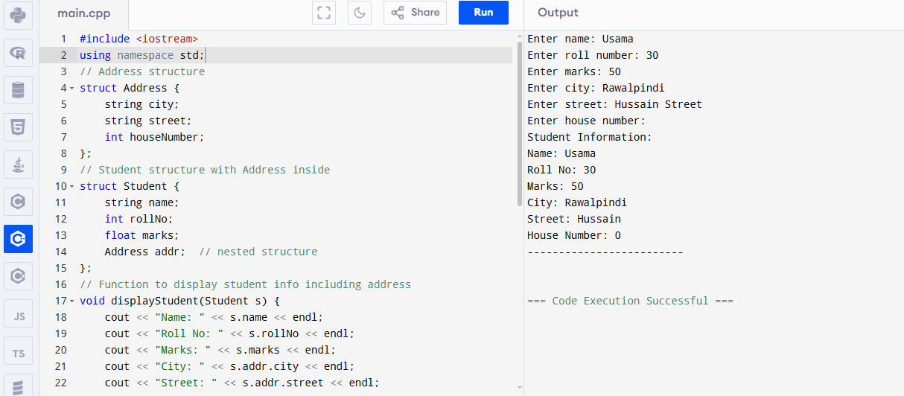

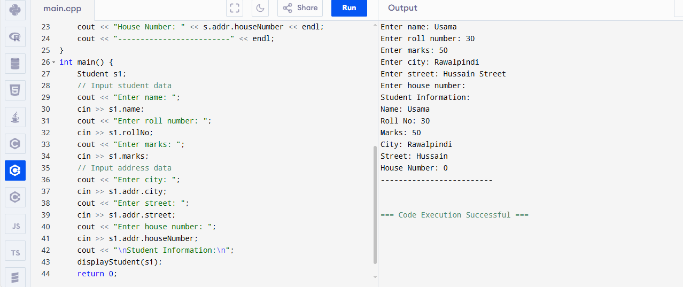

**File Handling in C++**

## **📂 What is File Handling?**

File Handling means reading data from files and writing data to files using your program.

This helps to save data permanently, even after the program ends.

## **🛠️ Basics of File Handling in C++**

C++ provides a library called <fstream> to work with files.  
 There are 3 main classes:

* ofstream — to write data to a file
* ifstream — to read data from a file
* fstream — for both reading and writing

## 

## **Step 1: Writing to a File**

#include <iostream>

#include <fstream> // file stream library

using namespace std;

int main() {

ofstream outFile("data.txt"); // open file for writing

if (!outFile) {

cout << "Error opening file!" << endl;

return 1;

}

outFile << "Hello, this is a file handling example.\n";

outFile << "Writing this line to the file.\n";

outFile.close(); // close the file

cout << "Data written to file successfully!" << endl;

return 0;

}

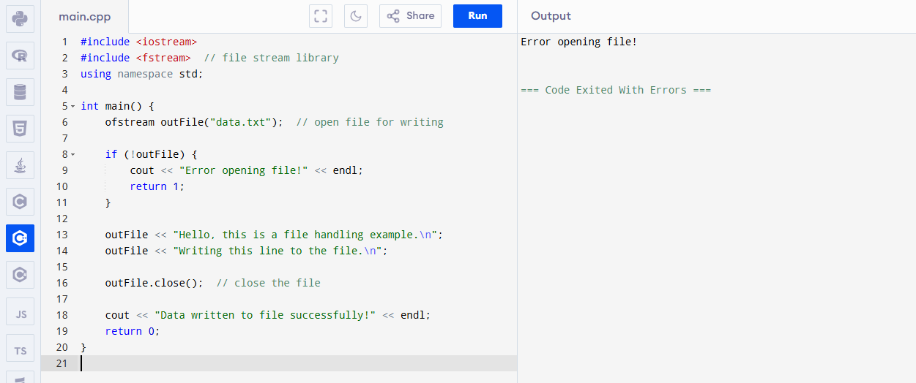

## **🖥️ What happens here?**

* ofstream outFile("data.txt"); opens (or creates) a file named **data.txt** for writing
* outFile << "text" writes the text to the file
* outFile.close(); closes the file to save it properly

**Step 2: Reading from a File**

#include <iostream>

#include <fstream>

#include <string>

using namespace std;

int main() {

ifstream inFile("data.txt"); // open file for reading

if (!inFile) {

cout << "Error opening file!" << endl;

return 1;

}

string line;

while (getline(inFile, line)) { // read line by line

cout << line << endl;

}

inFile.close(); // close the file

return 0;

}

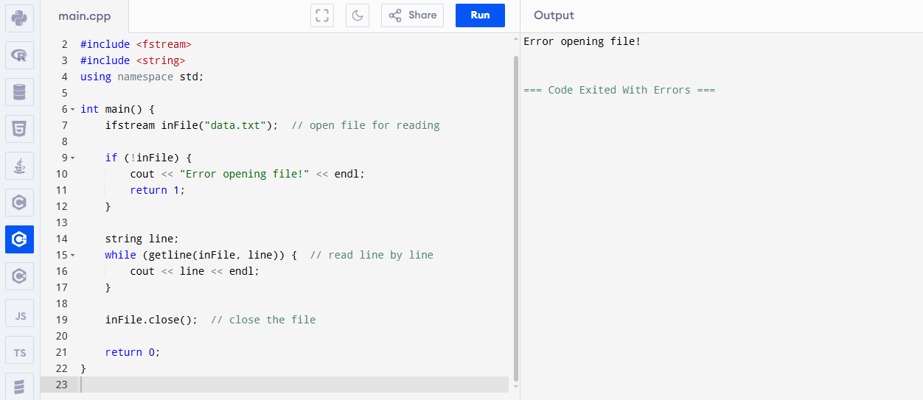

## **🖥️ What happens here?**

* ifstream inFile("data.txt"); opens the file for reading
* getline(inFile, line) reads the file line by line until the end
* prints each line to the screen